Diesel Black Gold shearling leather jacket
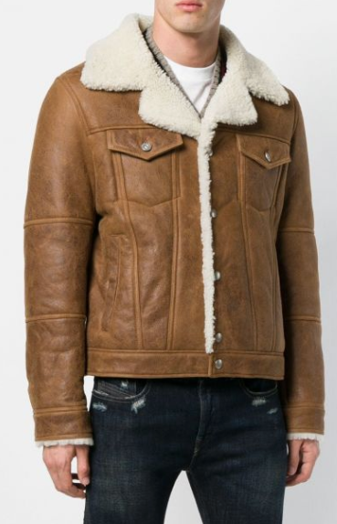
$2250

Tan brown sheepskin shearling leather jacket from Diesel Black Gold featuring a snap button closure, front flap pockets, a fitted silhouette, a shearling-trimmed notched collar, a shearling lining and shearling details on the back of sleeves.

